EMAIL SIGNATURE

Want to spread the word every day? If your institution allows you to modify your email signature, you can easily let everybody know that you’re presenting at the ISHLT 2025 Annual Meeting!

- Open the “add new signature” menu within your email program settings. To do this in Outlook, you typically need to start a blank message, then click Signatures, then click “Add New Signature.”
- Make sure HTML is enabled.
- Copy and paste the below signature into the body of the new signature menu.
- Feel free to add any content you wish, such as the date and time of your session. For example: “I’m speaking at ISHLT2025 on XX April at XX:XX a.m./p.m.”
- Email systems may import the images and text in different ways, changing the look. You may want to make edits to create what you see below or format it to suit your company branding.

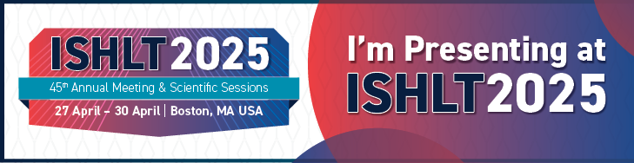
I’M PRESENTING A ISHLT2025 | 27-30 APRIL, 2025

